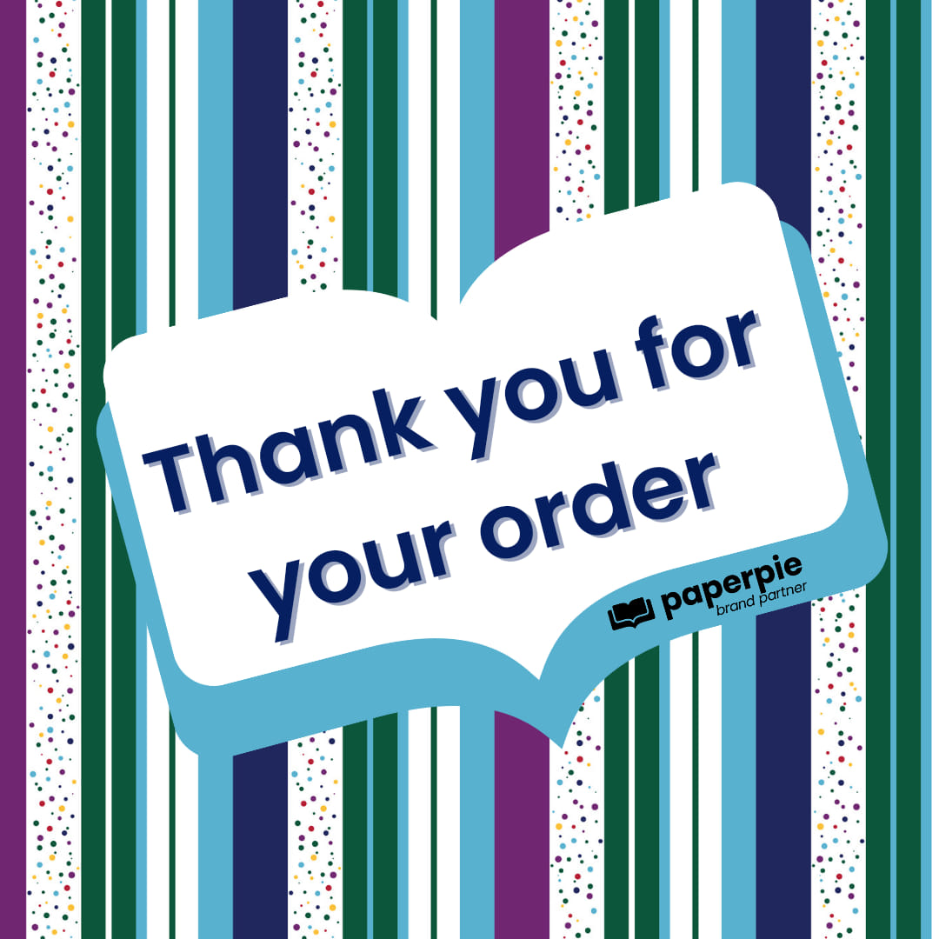

Dear Parents,

I am excited to announce that **Crossroads Elementary** is holding a **PaperPie Book Fair!** Purchases made from the book fair will be matched up to **50%** to provide FREE books and/or cash for your child’s school.

The book fair will officially be open from **Tuesday, March 25th to Friday, March 28th** but you can take advantage of our **PaperPie Day specials** by **shopping online starting today**! Use this link to view our full catalog and to shop online:

https://paperpie.com/brandpartner/C8022/event/[4055816](https://paperpie.com/brandpartner/C8022/event/4055816)

You may place your order in one of three ways.

1. If you **order online**, the order will be sent directly to your home and the school will get credit! Family and friends who are not local can order through the website, too.
2. **Browse on-line,** then complete the order form on the back of this letter and return it by **Wednesday, March 26th.** If I have the items in stock, the order will go home that day. If I don’t have an item in stock, I will order it and deliver it to the school by April 9th with FREE shipping.
3. You and your child can **shop in-person** during the school day on Tuesday through Friday at noon and at the Content Night on Thursday.If your child(ren) will be shopping on their own and you don’t want to send in cash, you can send money through **Venmo** (@Janet-Ficca). Anything not spent will be refunded back to you! I also take all credit cards and Apple Pay.

Please do not hesitate to contact me if you have any questions. Follow me on Facebook (Ladybug’s Librairie) and/or Instagram (@757ladybug) for the most up to date info on titles, specials and local events where you can shop

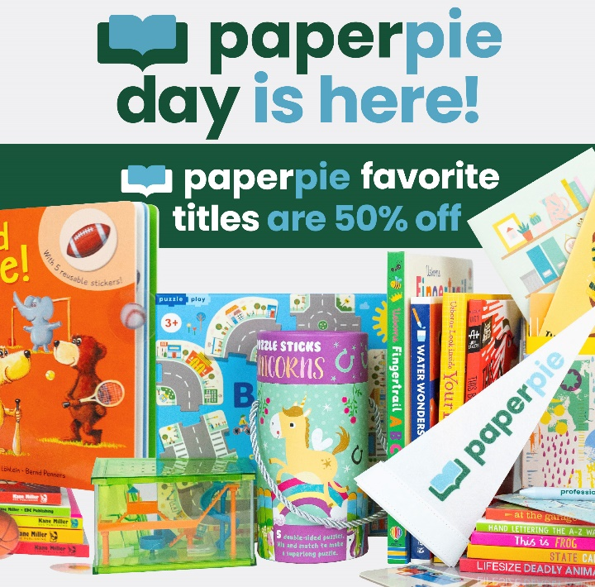with me in-person.

Janet D Ficca

PaperPie Educational Consultant

(757) 646-2684

ladybugslibrairie@gmail.com

Make sure to check out all our PaperPie Day specials **online** through March 14th!

Student’s Name: ______________________________ Grade: ____________

Parent’s Name: _________________________________________________

Phone: _______________________ Email: ___________________________

**Book Fair Wish List / Order Form:**

Title: Price:

1. _____________________________________________ ____________

2. _____________________________________________ ____________

3. _____________________________________________ ____________

4. _____________________________________________ ____________

5. _____________________________________________ ____________

6. _____________________________________________ ____________

7. _____________________________________________ ____________

8. _____________________________________________ ____________

Total Enclosed (Please add 6% sales tax) $ ____________

Payment info:

_____ Invoice Me _____ Venmo _____ Cash

All orders are due by Wednesday, March 26th to receive **FREE shipping**

or use the link to shop online**:** <https://paperpie.com/brandpartner/C8022/event/4055816>

Books not in stock will be delivered by **Wednesday, April 9th**.

I would like more information on earning free and discounted books by hosting a home show, book fair, fundraiser, or the income opportunity with PaperPie.